**Exercise 7: Return Data from a Scalar Function**

**Goal: Return the annual salary for a specific employee using `fn_CalculateAnnualSalary`.**

**Steps:**

**1. Execute the `fn_CalculateAnnualSalary` function for an employee with `EmployeeID = 1`.**

**2. Verify the result**

CREATE FUNCTION fn_CalculateAnnualSalary (@EmployeeID INT)

RETURNS DECIMAL(10,2)

AS

BEGIN

DECLARE @AnnualSalary DECIMAL(10,2);

SELECT @AnnualSalary = Salary * 12

FROM Employees

WHERE EmployeeID = @EmployeeID;

RETURN @AnnualSalary;

END;

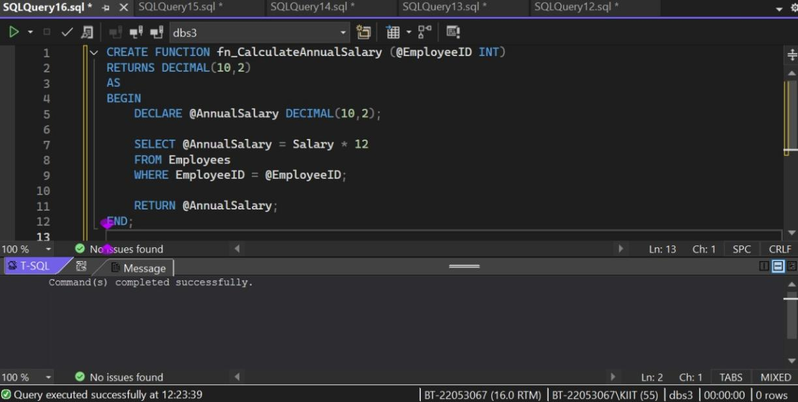

SELECT dbo.fn_CalculateAnnualSalary(1) AS AnnualSalary;

